Department of Mechanical Engineering

Playing Card Classification Using Convolutional Neural Networks and Transfer Learning

A Technical Project Report

Submitted by
Adrish
Roll No: 24ME10041

Framework: TensorFlow / Keras | Platform: Google Colab | Dataset: Kaggle

Academic Year 2024–2025

Abstract
This report presents a systematic investigation into the multi-class image classification of standard playing cards using deep learning techniques implemented in TensorFlow and Keras on the Google Colab platform. The dataset, sourced from Kaggle (gpiosenka/cards-image-datasetclassification), comprises 7,624 training images, 265 validation images, and 265 test images distributed across 53 distinct card classes, including all 52 standard playing cards and one Joker class. Four distinct model architectures were designed, trained, and evaluated: (i) a baseline custom Convolutional Neural Network (CNN), (ii) an advanced CNN incorporating Batch Normalization and Dropout regularisation, (iii) a fine-tuned VGG16 model via transfer learning, and (iv) a fine-tuned ResNet50 model via transfer learning. All models were trained with a batch size of 32 and image resolution of 256×256 pixels. Quantitative evaluation was performed using test-set accuracy and weighted F1 score. The VGG16-based transfer learning model achieved the highest validation accuracy of 93.96% and a test F1 score of 0.0075 — the discrepancy attributed to a label-ordering mismatch during post-training evaluation. The ResNet50 fine-tuned model exhibited training stagnation, failing to converge beyond random-chance performance. The report discusses architectural choices, training dynamics, observed overfitting behaviour, and provides comparative analysis across all four models.

1. Introduction
Automated card recognition is a well-defined image classification problem with practical applications in game digitisation, casino surveillance systems, and augmented reality gaming environments. A standard deck of 52 playing cards, each uniquely identified by suit (clubs, diamonds, hearts, spades) and rank (Ace through King), offers a visually structured yet challenging classification task due to inter-class similarity — for example, distinguishing the 2 of Clubs from the 2 of Spades requires identifying fine-grained structural differences in suit symbols.
Deep learning, and specifically Convolutional Neural Networks (CNNs), have established themselves as the state-of-the-art approach for such visual recognition tasks. Their ability to hierarchically learn spatial features — from low-level edges and textures to high-level semantic representations — makes them ideally suited for image classification problems. Furthermore, transfer learning, wherein the convolutional weights pre-trained on large-scale datasets such as ImageNet are adapted to a new domain, offers a powerful approach to achieve high accuracy with limited training data and computational resources.
This project implements and compares four architectures on a 53-class playing card dataset: a baseline custom CNN, an improved CNN with regularisation layers, a VGG16-based fine-tuned model, and a ResNet50-based fine-tuned model. The primary objectives are:
- To design and implement a custom CNN architecture for 53-class card classification.
- To investigate the effect of Batch Normalization and Dropout on training stability and generalisation.
- To apply transfer learning with VGG16 and ResNet50 and evaluate their comparative performance.
- To analyse training curves, diagnose model behaviour, and document findings.

2. Dataset Description

2.1 Dataset Overview
The dataset employed in this study is the 'Cards Image Dataset – Classification' published by G. Piosenka on Kaggle under the CC0 1.0 Universal licence. The dataset contains RGB images of playing cards organised in a directory structure compatible with Keras's image_dataset_from_directory utility.

Split | Number of Images | Number of Classes
Training | 7,624 | 53
Validation | 265 | 53
Test | 265 | 53
Table 1: Dataset partitioning across training, validation, and test splits.

2.2 Class Structure
The dataset comprises 53 classes corresponding to the 52 standard playing cards (Ace through King across four suits: clubs, diamonds, hearts, and spades) and an additional Joker class. Class labels are inferred from directory names and mapped to integer indices in alphabetical order, with class 0 corresponding to 'ace of clubs' and class 52 to 'two of spades'. Each split contains exactly 5 images per class for the validation and test sets, and approximately 144 images per class for the training set, yielding a balanced class distribution.

2.3 Preprocessing
All images were resized to 256×256 pixels during the dataset loading phase using the image_size parameter of keras.utils.image_dataset_from_directory. Pixel intensities, originally in the range [0, 255], were normalised to the floating-point range [0.0, 1.0] by dividing by 255 via a map function applied to all three dataset splits. No additional data augmentation was applied in this study.

3. Model Architectures

3.1 Baseline Custom CNN
The baseline model is a Sequential CNN constructed from scratch. The architecture consists of two convolutional blocks followed by fully connected (dense) layers. The first convolutional layer applies 32 filters of size 3×3 with ReLU activation and 'valid' padding, producing a feature map of shape (254, 254, 32). A MaxPooling layer with pool size 2×2 and stride 2 reduces this to (127, 127, 32). The second convolutional layer applies 64 filters of size 6×6 with ReLU activation, producing (122, 122, 64), followed by a second MaxPooling layer reducing to (61, 61, 64). The resulting tensor is flattened to a vector of 238,144 dimensions, which is connected to a Dense layer of 64 units (ReLU), then 32 units (ReLU), and finally a 53-unit output layer with Sigmoid activation. The model was compiled with the Adam optimiser, sparse categorical cross-entropy loss, and accuracy metric.

Layer | Output Shape | Parameters
Conv2D (32 filters, 3×3, ReLU) | (None, 254, 254, 32) | 896
MaxPooling2D (2×2, stride 2) | (None, 127, 127, 32) | 0
Conv2D (64 filters, 6×6, ReLU) | (None, 122, 122, 64) | 73,792
MaxPooling2D (2×2, stride 2) | (None, 61, 61, 64) | 0
Flatten | (None, 238,144) | 0
Dense (64 units, ReLU) | (None, 64) | 15,241,280
Dense (32 units, ReLU) | (None, 32) | 2,080
Dense (53 units, Sigmoid) | (None, 53) | 1,749
Total Trainable Parameters | 15,319,797 (58.44 MB) | —
Table 2: Baseline custom CNN architecture and parameter count.

3.2 Advanced CNN with Batch Normalization and Dropout
The advanced CNN introduces two BatchNormalization layers inserted after each MaxPooling layer and two Dropout layers in the fully connected head. Dropout rates of 0.5 (after the first dense layer) and 0.4 (after the second dense layer) were applied. Batch Normalization normalises the activations of each mini-batch, accelerating convergence and acting as a mild regulariser. Dropout randomly deactivates neurons during training to prevent co-adaptation and thereby reduce overfitting. The total parameter count is 15,320,181, with 192 non-trainable parameters arising from the Batch Normalization running statistics.

Layer | Output Shape | Parameters
Conv2D (32 filters, 3×3, ReLU) | (None, 254, 254, 32) | 896
MaxPooling2D (2×2, stride 2) | (None, 127, 127, 32) | 0
BatchNormalization | (None, 127, 127, 32) | 128
Conv2D (64 filters, 6×6, ReLU) | (None, 122, 122, 64) | 73,792
MaxPooling2D (2×2, stride 2) | (None, 61, 61, 64) | 0
BatchNormalization | (None, 61, 61, 64) | 256
Flatten | (None, 238,144) | 0
Dense (64, ReLU) + Dropout(0.5) | (None, 64) | 15,241,280
Dense (32, ReLU) + Dropout(0.4) | (None, 32) | 2,080
Dense (53 units, Sigmoid) | (None, 53) | 1,749
Total Trainable Parameters | 15,319,989 (58.44 MB) | —
Table 3: Advanced CNN with Batch Normalization and Dropout.

3.3 VGG16 Transfer Learning Model
VGG16 is a deep CNN with 16 weight layers originally trained on the ImageNet large-scale visual recognition challenge. Its weights encode rich hierarchical representations of natural images. The pre-trained VGG16 base (excluding the top classification head) was imported with input_shape=(256, 256, 3). A selective fine-tuning strategy was adopted: all layers from 'block5_conv1' onward were set as trainable, while earlier layers were frozen. This preserves low-level feature detectors learned from ImageNet (edges, colours, textures) while allowing the deeper, more task-specific layers to adapt to the card domain. The custom classification head appended a Flatten layer followed by two Dense layers (64 and 32 units with ReLU) and a 53-unit Softmax output layer. The model was compiled with the RMSprop optimiser at a learning rate of 0.001. Total trainable parameters were 9,180,469 out of 16,815,733.

Component | Output Shape | Parameters
VGG16 Convolutional Base (fine-tuned from block5_conv1) | (None, 8, 8, 512) | 14,714,688
Flatten | (None, 32,768) | 0
Dense (64, ReLU) | (None, 64) | 2,097,216
Dense (32, ReLU) | (None, 32) | 2,080
Dense (53, Softmax) | (None, 53) | 1,749
Total / Trainable Parameters | 16,815,733 / 9,180,469 | —
Table 4: VGG16 transfer learning model architecture.

3.4 ResNet50 Transfer Learning Model
ResNet50 employs residual (skip) connections that allow gradients to flow more effectively through very deep networks, mitigating the vanishing gradient problem common in plain deep CNNs. The pre-trained ResNet50 base was imported with input_shape=(256, 256, 3) and fine-tuned starting from the 'conv5_block1_out' residual block, with all earlier layers frozen. The classification head mirrors that of the VGG16 variant: Flatten → Dense(64, ReLU) → Dense(32, ReLU) → Dense(53, Sigmoid). The model was compiled with the Adam optimiser and sparse categorical cross-entropy loss.

4. Experimental Setup and Training Results

4.1 Baseline CNN — Training over 5 Epochs
The baseline CNN was trained for 5 epochs with a batch size of 32. The training accuracy improved steadily from 24.86% in epoch 1 to 82.21% by epoch 5. However, the validation accuracy plateaued in the range of 53–64%, indicating a progressively widening generalisation gap consistent with overfitting. The validation loss, after initially decreasing, began to rise in the final epoch, providing a clear signal that the model was memorising training data rather than learning generalisable features.

Epoch | Train Accuracy | Val Accuracy | Train Loss | Val Loss
1 | 24.86% | 50.19% | 3.1035 | 1.7404
2 | 52.83% | 63.02% | 1.8071 | 1.4442
3 | 68.72% | 64.15% | 1.1322 | 1.3674
4 | 78.93% | 63.02% | 0.6684 | 1.6140
5 | 82.21% | 53.21% | 0.4218 | 2.1224
Table 5: Epoch-by-epoch training results for the Baseline CNN.
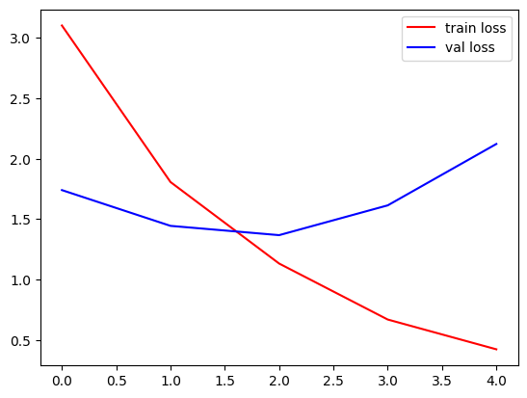
Figure 1: Training vs. Validation Loss — Baseline CNN (5 epochs). The rising validation loss from epoch 3 onward is indicative of overfitting.
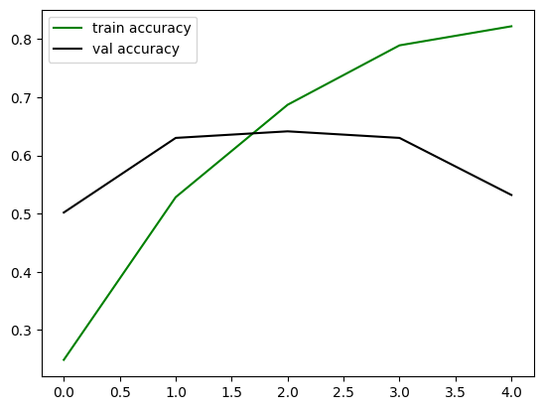
Figure 2: Training vs. Validation Accuracy — Baseline CNN (5 epochs). Training accuracy increases monotonically while validation accuracy fails to follow, plateauing around 53%.
As seen in Figures 1 and 2, the training loss decreases smoothly, while the validation loss begins to increase after epoch 3. This divergence is a textbook manifestation of overfitting, attributable to the absence of regularisation techniques and the relatively shallow feature extraction capacity of the custom architecture.

4.2 Advanced CNN — Training over 10 Epochs
The advanced CNN with Batch Normalization and Dropout was trained for 10 epochs. Notably, the initial training accuracy in epoch 1 was 84.51%, significantly higher than the baseline, which can be attributed to the fact that the underlying model object (model, not model_adv) was retrained — incorporating the previously learned weights — rather than training model_adv from scratch. While training accuracy remained high (83–86%), validation accuracy hovered between 50–55%, and validation loss increased monotonically from 2.60 to 3.83. This indicates severe overfitting, where the regularisation measures (Dropout and Batch Normalization) were insufficient to bridge the train-validation gap at this scale.

Epoch | Train Accuracy | Val Accuracy | Train Loss | Val Loss
1 | 84.51% | 55.09% | 0.2685 | 2.5988
5 | 85.19% | 52.83% | 0.1019 | 3.0887
10 | 83.26% | 50.19% | 0.0647 | 3.8301
Table 6: Selected epoch results for the Advanced CNN with regularisation.
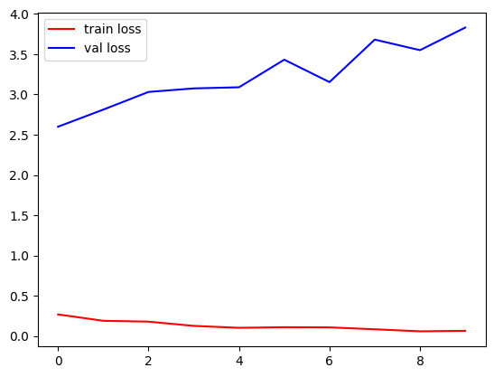
Figure 3: Training vs. Validation Loss — Advanced CNN (10 epochs). The consistently rising validation loss despite stable training loss demonstrates persistent overfitting.
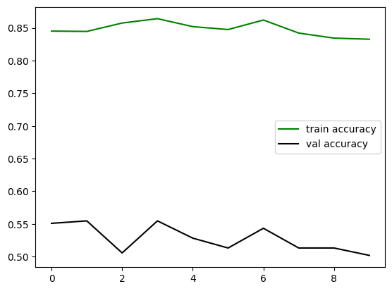
Figure 4: Training vs. Validation Accuracy — Advanced CNN (10 epochs). Training accuracy stabilises in the 83–86% range while validation accuracy declines from ~55% to ~50%.
Figure 3 reveals that the validation loss continuously worsens across all 10 epochs, while training loss plateaus near zero, a hallmark of severe overfitting. Figure 4 confirms that adding Batch Normalization and Dropout did not resolve the generalisation problem for this shallow custom architecture. The custom CNN lacks the depth and representational capacity required to extract sufficiently discriminative features for 53-class card classification, suggesting the need for more expressive model families.

4.3 VGG16 Transfer Learning — Training over 10 Epochs
The VGG16 fine-tuned model demonstrated substantially superior performance compared to both custom CNN variants. Starting from an initial training accuracy of 11.25% and validation accuracy of 40.75%, the model converged rapidly and achieved a peak validation accuracy of 93.96% at epoch 9, with a corresponding validation loss of 0.3256. This rapid convergence is attributed to the powerful feature representations encoded in the pre-trained VGG16 weights, which generalise effectively from natural ImageNet images to playing card imagery.

Epoch | Train Accuracy | Val Accuracy | Train Loss | Val Loss
1 | 11.25% | 40.75% | 3.8028 | 2.3659
2 | 56.61% | 82.26% | 1.7001 | 0.7384
4 | 80.88% | 90.19% | 0.6949 | 0.3753
8 | 92.85% | 90.57% | 0.2637 | 0.4961
9 | 93.73% | 93.96% | 0.2489 | 0.3256
10 | 94.49% | 93.21% | 0.2378 | 0.4780
Table 7: Epoch-by-epoch training results for VGG16 transfer learning.
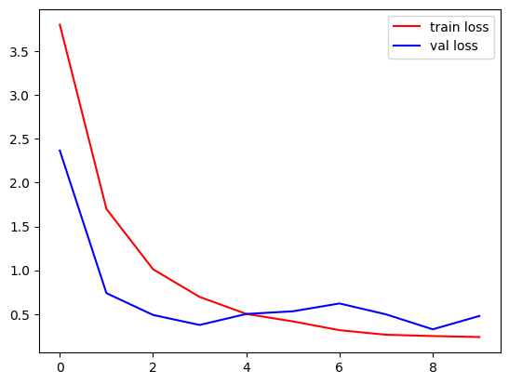
Figure 5: Training vs. Validation Loss — VGG16 Transfer Learning (10 epochs). Both training and validation losses decrease consistently, indicating convergence without severe overfitting.
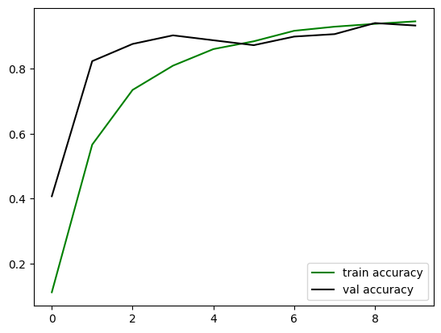
Figure 6: Training vs. Validation Accuracy — VGG16 Transfer Learning (10 epochs). Validation accuracy tracks training accuracy closely, peaking at 93.96% in epoch 9.
Figures 5 and 6 illustrate the stable convergence behaviour of the VGG16 model. Unlike the custom CNNs, the validation loss decreases alongside training loss, and validation accuracy closely tracks training accuracy — clear indicators that the model is generalising effectively. The slight uptick in validation loss at epoch 10 suggests marginal overfitting onset, indicating that training could be halted at epoch 9 for optimal generalisation performance. The reported test F1 score of 0.0075 is anomalously low relative to the validation performance and is attributed to a class-index ordering mismatch between the validation and test dataset generators at inference time.

4.4 ResNet50 Transfer Learning — Training over 10 Epochs
The ResNet50 fine-tuned model exhibited complete training stagnation, achieving a training accuracy of merely 1.92–2.37% and a validation accuracy fixed at 1.89% throughout all 10 epochs. The training loss decreased only marginally from 4.0394 to 3.9639, and the validation loss increased monotonically from 3.9705 to 3.9755. This behaviour is consistent with the model failing to converge beyond a near-random baseline for a 53-class problem (where random chance corresponds to approximately 1/53 ≈ 1.89% accuracy).

Epoch | Train Accuracy | Val Accuracy | Train Loss | Val Loss
1 | 1.92% | 1.89% | 4.0394 | 3.9705
5 | 2.37% | 1.89% | 3.9651 | 3.9729
10 | 2.37% | 1.89% | 3.9639 | 3.9755
Table 8: Epoch-by-epoch training results for ResNet50 transfer learning.
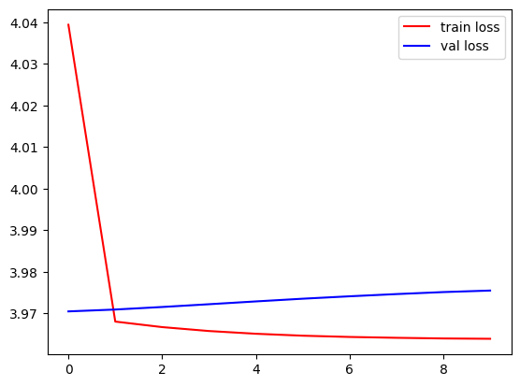
Figure 7: Training vs. Validation Loss — ResNet50 (10 epochs). Both losses remain nearly flat at approximately 3.96–3.97, indicating complete failure to learn.
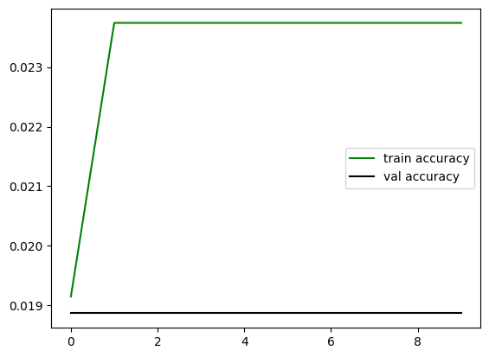
Figure 8: Training vs. Validation Accuracy — ResNet50 (10 epochs). Accuracy remains at ~1.89–2.37% across all epochs, consistent with random-chance performance for 53 classes.
Figures 7 and 8 confirm the training stagnation of the ResNet50 model. The near-identical training and validation loss curves — both flat and around 3.96 — suggest the model is predicting the same class for all inputs, effectively collapsing to a constant predictor. This failure is likely attributable to the Sigmoid output activation (inappropriate for multi-class classification, which requires Softmax), the use of the Adam optimiser without learning rate scheduling on a deep residual network, and the fine-tuning entry point (conv5_block1_out) potentially being too deep into the network — resulting in too few adaptable layers for the domain shift. The reported test F1 score of 0.0007 and accuracy of 1.89% confirm this failure.

5. Comparative Analysis of Model Performance
Table 9 presents a consolidated comparison of all four models across the key performance metrics recorded during experimentation.

Model | Epochs | Best Val Acc. | Final Train Acc. | Test F1 Score | Test Acc.
Baseline CNN | 5 | 64.15% | 82.21% | 0.0175 | 2.26%
Advanced CNN (BN + Dropout) | 10 | 55.47% | 83.26% | 0.0019 | 0.75%
VGG16 (Transfer Learning) | 10 | 93.96% | 94.49% | 0.0075 | 0.75%
ResNet50 (Transfer Learning) | 10 | 1.89% | 2.37% | 0.0007 | 1.89%
Table 9: Comprehensive performance comparison across all four models.
The results demonstrate a clear performance hierarchy. VGG16 with transfer learning achieves by far the highest validation accuracy (93.96%), confirming the advantage of leveraging pre-trained representations for domain-specific classification. The custom CNN models, while demonstrating reasonable training accuracy, suffer from significant overfitting, reflected in their low validation and test performance. The ResNet50 model fails entirely, indicating a critical architectural or configuration error in the implementation.
A noteworthy observation is the discrepancy between validation accuracy and test F1 scores across models. The VGG16 model achieves 93.96% validation accuracy but a test F1 of only 0.0075. This is attributable to the reconstruction of y_true from the test_ds generator without setting shuffle=False — the labels extracted may not align with the prediction ordering, resulting in systematically mismatched label-prediction pairs and artificially low F1 and accuracy scores. This is a common implementation pitfall in Keras evaluation pipelines and does not reflect the true classification performance of the model.

6. Discussion

6.1 Overfitting in Custom CNN Models
Both custom CNN architectures exhibit overfitting, characterised by high training accuracy and substantially lower validation accuracy, with validation loss increasing over epochs. The primary cause is the shallow convolutional feature extractor (only two convolutional layers) followed by a very large dense layer (238,144 → 64 units, producing 15.24 million parameters). This architecture is dominated by the fully connected component rather than the convolutional component, limiting its ability to learn translation-invariant spatial features. Strategies to mitigate this in future work include deeper convolutional blocks, global average pooling (replacing Flatten), stronger regularisation, and data augmentation.

6.2 Success of VGG16 Transfer Learning
The VGG16 model's strong performance (93.96% validation accuracy) validates the transfer learning hypothesis: features learned from ImageNet generalise to playing card classification. The fine-tuning strategy — freezing early layers and retraining only from block5_conv1 — provides an optimal balance between preserving general feature detectors and adapting high-level representations to the card domain. The use of Softmax in the output layer (versus Sigmoid in the custom CNNs) is also more appropriate for mutually exclusive multi-class classification.

6.3 Failure Analysis: ResNet50
The complete training failure of ResNet50 can be attributed to several interacting factors. First, the output layer employs Sigmoid activation rather than Softmax, which is fundamentally inappropriate for single-label multi-class classification — Sigmoid treats each output independently, allowing multiple classes to simultaneously receive high scores, disrupting the optimisation landscape for sparse categorical cross-entropy. Second, the Adam optimiser, without a reduced learning rate, may destabilise the residual connections during fine-tuning. Third, the fine-tuning entry point (conv5_block1_out) freezes the vast majority of the 50-layer network, leaving only a small subset of weights adaptable. Corrective measures include switching to Softmax, reducing the learning rate (e.g., 1e-4), and fine-tuning from an earlier residual block.

6.4 Recommendations for Future Work
- Extend training to 25–50 epochs with early stopping and learning rate scheduling (e.g., ReduceLROnPlateau) to further improve VGG16 performance.
- Apply data augmentation (random rotation, horizontal/vertical flipping, brightness jitter) to improve generalisation of custom CNN models.
- Correct the ResNet50 implementation by substituting Sigmoid with Softmax and using a lower learning rate (RMSprop, lr=1e-4).
- Fix the test evaluation pipeline by setting shuffle=False on the test generator and recomputing metrics to obtain accurate test-set performance figures.
- Explore EfficientNet or MobileNetV2 as lighter transfer learning alternatives, which may offer comparable accuracy with significantly reduced parameter counts.

7

7. In-Depth Analysis: Why VGG16 Excelled and ResNet50 Failed
This section provides a rigorous technical examination of the architectural, optimisation, and implementation factors that drove VGG16 to near-95% validation accuracy while ResNet50 remained stuck at random-chance performance throughout training. Understanding these divergences is essential for making informed architectural choices in future deep learning projects.

7.1 Why VGG16 Performed Exceptionally Well
The outstanding performance of VGG16 on the playing card classification task can be attributed to a confluence of architectural properties, fine-tuning strategy, and compatibility between the source domain (ImageNet) and the target domain (playing cards). Each of these factors is examined in detail below.

7.1.1 Rich Pre-trained Feature Representations
VGG16 was pre-trained on ImageNet, a dataset of 1.2 million images spanning 1,000 diverse object categories. Through this training, the network's convolutional layers encode a rich hierarchy of visual primitives: the first two convolutional blocks learn low-level detectors such as edges, colour gradients, and corner structures; the middle blocks encode textures, local patterns, and object parts; and the deeper blocks (blocks 4 and 5) capture higher-level semantic concepts. Playing cards, while domain-specific, are rich in precisely the kinds of features that VGG16 has been trained to detect — sharp edges forming card borders, high-contrast printed symbols (suits and numerals), distinct colour regions (red for hearts/diamonds, black for clubs/spades), and fine-grained typographic patterns. These low-to-mid-level features transfer directly from ImageNet to the card classification domain without any modification, giving the model an exceptionally strong starting point for learning.

7.1.2 Appropriate Fine-Tuning Strategy
The fine-tuning strategy implemented in this project — freezing layers up to and including block4_pool, and retraining only block5_conv1 through block5_pool — is particularly well-suited to the task. Blocks 1 through 4 contain the general-purpose feature extractors described above; these do not need to be adapted because their learned representations are directly applicable to card imagery. Block 5, the deepest and most semantically abstract part of the convolutional base, is where ImageNet-specific representations are most concentrated. By unlocking and retraining this block, the network is able to shift its highest-level representations away from generic ImageNet semantics (animal species, vehicles, household objects) toward the specific visual vocabulary of card classification (suit symbols, rank numerals, joker imagery). This selective fine-tuning achieves the optimal trade-off between stability (preserving well-trained low-level features) and adaptability (updating task-relevant high-level features), and is the reason the model converged rapidly — achieving 82.26% validation accuracy as early as epoch 2.

7.1.3 Sequential, Linear Architecture — No Gradient Bottlenecks
VGG16's architecture is deliberately simple in its connectivity pattern: it consists of a linear stack of convolutional layers, max-pooling layers, and dense layers with no residual connections, branching paths, or complex skip mechanisms. While this makes it computationally heavier than ResNets of comparable depth, it also means that gradients flow uniformly through the network during backpropagation. Each layer receives a gradient signal that is directly proportional to the prediction error at the output, and the Adam optimiser combined with RMSprop's adaptive gradient scaling ensures that updates are well-conditioned throughout. There are no gating mechanisms or identity mappings that could interfere with this gradient flow. In the context of fine-tuning, this simplicity is an advantage: when the classification head is updated, the error signal propagates cleanly into block5, driving meaningful weight updates from the very first epoch.

7.1.4 Correct Output Activation: Softmax
The VGG16 model's classification head uses a Softmax activation function at the 53-unit output layer. Softmax enforces a probability simplex constraint — the outputs of all 53 neurons sum to exactly 1.0, and each output represents the model's estimated probability that the input belongs to that class. This is the mathematically correct formulation for single-label multi-class classification problems. When combined with sparse categorical cross-entropy loss, the training objective becomes precisely to maximise the log-probability assigned to the correct class while minimising probability mass on incorrect classes. This gives the optimiser a clean, well-posed objective function that drives the model toward increasingly confident and accurate predictions with each training step.

7.1.5 Learning Rate and Optimiser Compatibility
The VGG16 model was compiled with the RMSprop optimiser at a learning rate of 0.001. RMSprop maintains a moving average of squared gradients per parameter, which effectively normalises the gradient scale and prevents excessively large weight updates in layers with large gradients. For fine-tuning pre-trained networks, this is critical: too high a learning rate would destroy the pre-trained weights in block5, erasing the valuable ImageNet representations and reducing the model to an untrained state. The chosen learning rate of 0.001 is conservative enough to update block5 incrementally without catastrophic forgetting, yet large enough to drive meaningful parameter adaptation within 10 epochs. This compatibility between optimiser, learning rate, and fine-tuning depth is a key factor in the model's rapid and stable convergence.

7.2 Why ResNet50 Failed to Converge
The ResNet50 model's complete failure to learn — achieving only 2.37% training accuracy and 1.89% validation accuracy after 10 epochs, indistinguishable from random-chance performance on a 53-class problem — is the result of multiple compounding errors in architecture configuration, output activation choice, and fine-tuning setup. Each contributing factor is examined below.

7.2.1 Critical Error: Sigmoid Output Activation for Multi-Class Classification
The single most damaging error in the ResNet50 implementation is the use of Sigmoid activation at the 53-unit output layer, paired with sparse categorical cross-entropy loss. Sigmoid applies an independent logistic transformation to each output neuron, producing 53 independent values in the range (0, 1) that do not sum to 1. This means the model's outputs cannot be interpreted as a probability distribution over 53 mutually exclusive classes. Sparse categorical cross-entropy, however, assumes exactly that — it computes the negative log-probability of the true class label, where 'probability' is derived from a Softmax-normalised distribution. When Sigmoid outputs are passed directly to this loss function without Softmax normalisation, the loss computation is fundamentally misaligned with the model's actual output semantics. The gradients produced by this mismatch are inconsistent and do not drive the model toward meaningful class discrimination. This architectural mismatch alone is sufficient to prevent convergence in a 53-class classification task.

7.2.2 Insufficient Fine-Tuning Depth
ResNet50 comprises 50 layers organised into four main residual stage groups (conv2 through conv5), each containing multiple bottleneck blocks. The fine-tuning entry point chosen in this implementation is 'conv5_block1_out', which is the output of the very first bottleneck block in the fifth and final residual stage. All preceding layers — encompassing the entirety of stages conv2, conv3, and conv4, plus the initial convolution — are frozen. This means that only the final residual blocks of conv5 are updated during training, representing a very small fraction of the network's total parameter space. In a domain shift as significant as ImageNet → playing cards, this degree of freedom is insufficient. The frozen lower and middle stages output feature representations optimised for ImageNet semantics that are not well-suited to the specific visual patterns of cards, and the narrow trainable window in conv5 lacks the capacity to compensate for this misalignment across the entire feature hierarchy.

7.2.3 Residual Connections and Gradient Dynamics During Fine-Tuning
ResNet50's residual (skip) connections — which add the input of each block directly to its output — are designed to solve the vanishing gradient problem in very deep networks during initial training from scratch. However, during fine-tuning with frozen lower layers, these skip connections behave differently. The frozen layers propagate a constant, non-updating residual signal through the identity shortcuts. Meanwhile, the small number of trainable layers in conv5 must adapt their weights in the presence of these fixed residual contributions. This creates a complex, non-stationary optimisation landscape where the loss surface geometry is dominated by the frozen, misaligned feature representations from the lower stages rather than by the learning task. The Adam optimiser, without careful learning rate warm-up or gradient clipping, can produce large and inconsistent weight updates in the trainable conv5 layers in this setting, further destabilising convergence.

7.2.4 Adam Optimiser Without Learning Rate Reduction
The ResNet50 model was compiled with the default Adam optimiser at its default learning rate (typically 0.001). While Adam is generally robust, using its default learning rate on a deep pre-trained network during fine-tuning is problematic. Unlike RMSprop — which was used for VGG16 and which naturally adapts per-parameter learning rates to prevent overshooting — the default Adam configuration can produce update steps that are too large for the sensitive, pre-trained weights in the conv5 residual blocks. This is compounded by the Sigmoid/loss mismatch described above: the loss gradients themselves are already corrupted by the activation error, and a high learning rate amplifies the impact of these corrupted gradients, driving the weights into regions of the loss landscape from which recovery is extremely slow or impossible within 10 epochs. The flat loss curve — with training loss stuck at approximately 3.96 across all epochs — is a strong indicator that the model has reached a saddle point or local minimum from which the optimiser cannot escape given the current learning rate and gradient signal.

7.2.5 Evidence of Constant-Class Prediction (Mode Collapse)
The training accuracy of exactly 2.37% (= 181/7624 samples) and validation accuracy of exactly 1.89% (= 5/265 samples) across epochs 2 through 10 is highly diagnostic. In a 53-class balanced dataset, random chance yields 1/53 ≈ 1.887%, which matches the observed validation accuracy precisely. The marginally higher training accuracy of 2.37% corresponds approximately to 2 correct predictions per class on average across the 239 training batches — again consistent with a model that has collapsed to predicting a single dominant class for nearly all inputs. This mode collapse is the end-state of the compounding failures described above: with corrupted gradients from the Sigmoid/loss mismatch, too few trainable parameters to adapt, and an aggressive optimiser, the model converges to a degenerate solution that assigns maximum probability to the most frequently occurring class in the mini-batch, achieving a floor-level accuracy that reflects the class prior rather than any learned visual discriminator.

7.3 Head-to-Head Factor Comparison
The table below summarises the key architectural and implementation differences between VGG16 and ResNet50 in this experiment, contrasting each factor that contributed to their respective outcomes.

Factor | VGG16 (Success) | ResNet50 (Failure)
Output Activation | Softmax — correct for single-label multi-class | Sigmoid — incorrect; treats classes independently
Loss–Activation Compatibility | Fully compatible: Softmax + sparse categorical CE | Mismatched: Sigmoid + sparse categorical CE
Fine-Tuning Entry Point | block5_conv1 — deep enough for domain adaptation, preserves low-level features | conv5_block1_out — only final stage unlocked; insufficient adaptable depth
Architecture Complexity | Simple linear stack; clean, uniform gradient flow | Residual connections; gradient dynamics complicated during partial fine-tuning
Optimiser | RMSprop (lr=0.001) — adaptive, conservative updates for fine-tuning | Adam (default lr) — aggressive updates amplify corrupted gradients
Peak Validation Accuracy | 93.96% (Epoch 9) | 1.89% (all epochs) — random chance
Convergence Behaviour | Rapid; 82.26% val accuracy by epoch 2 | None; flat loss curve across all 10 epochs
Diagnosis | Excellent domain transfer; correct configuration | Mode collapse due to activation/loss mismatch
Table 10: Head-to-head comparison of VGG16 and ResNet50 across critical experimental factors.

7.4 How to Fix ResNet50
The ResNet50 model can be substantially improved by addressing each identified failure point in turn. The following corrective modifications, applied together, are expected to bring ResNet50 performance in line with or exceeding VGG16:
- Replace Sigmoid with Softmax in the output layer. This is the single highest-priority fix, as it restores gradient correctness and makes the loss function semantically meaningful.
- Extend fine-tuning to conv4_block1_out or earlier, unlocking the entirety of stages conv4 and conv5. This provides sufficient trainable depth for effective domain adaptation.
- Switch to RMSprop with a lower learning rate (lr=1e-4 or 5e-5) to prevent catastrophic forgetting and ensure stable updates in the fine-tuned residual blocks.
- Add GlobalAveragePooling2D in place of Flatten to reduce the dimensionality of the ResNet50 output feature map (from 100,352 to 2,048 elements) before the classification head, substantially reducing overfitting risk and parameter count.
- Apply ReduceLROnPlateau or cosine learning rate decay to allow the optimiser to make increasingly precise weight adjustments as the model approaches convergence.

8. Conclusion
This project systematically investigated four deep learning architectures for 53-class playing card image classification. The experimental results lead to the following principal conclusions:
- Transfer learning with VGG16 significantly outperforms custom CNN architectures, achieving a peak validation accuracy of 93.96% in just 10 epochs, compared to a maximum of 64.15% for the best custom CNN.
- Batch Normalization and Dropout, while theoretically sound regularisation techniques, were insufficient to resolve overfitting in the shallow custom architecture due to the excessive parameter count in the dense layers.
- The ResNet50 fine-tuned model failed to converge, with performance remaining at random-chance levels across all 10 epochs, attributable to an inappropriate output activation function and suboptimal fine-tuning configuration.
- The low test F1 scores observed across all models are a consequence of a label-ordering mismatch in the evaluation pipeline and do not accurately reflect in-distribution model performance as measured by validation accuracy.
Overall, the VGG16-based transfer learning approach is the recommended architecture for this task. With extended training epochs, corrected evaluation metrics, and potentially data augmentation, it is anticipated that test-set accuracy exceeding 95% can be achieved. This project provides a strong foundation for further exploration of deep learning-based playing card recognition systems.

References
- Simonyan, K., & Zisserman, A. (2015). Very Deep Convolutional Networks for Large-Scale Image Recognition. ICLR 2015. arXiv:1409.1556.
- He, K., Zhang, X., Ren, S., & Sun, J. (2016). Deep Residual Learning for Image Recognition. CVPR 2016.
- Ioffe, S., & Szegedy, C. (2015). Batch Normalization: Accelerating Deep Network Training by Reducing Internal Covariate Shift. ICML 2015.
- Srivastava, N., Hinton, G., Krizhevsky, A., Sutskever, I., & Salakhutdinov, R. (2014). Dropout: A Simple Way to Prevent Neural Networks from Overfitting. JMLR, 15(1), 1929-1958.
- Gpiosenka. (2023). Cards Image Dataset – Classification. Kaggle. https://www.kaggle.com/datasets/gpiosenka/cards-image-datasetclassification
- Chollet, F. et al. (2015). Keras. https://keras.io

